TECHNICAL COMMANDS
1.GREP
2.FIND

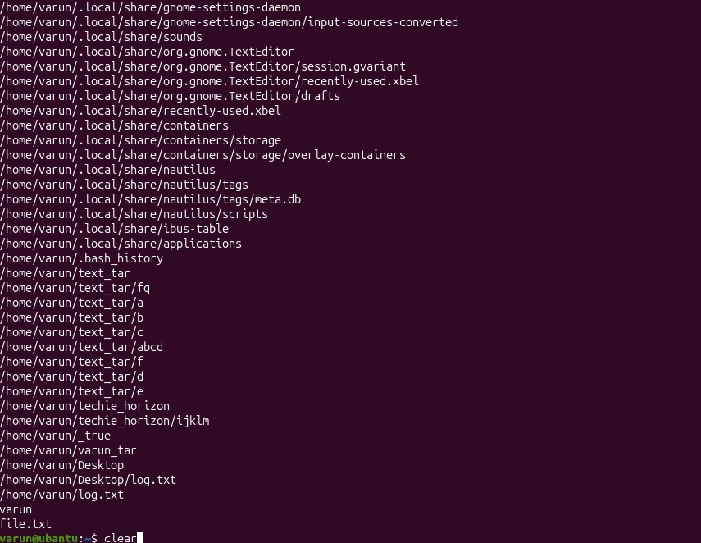

3. AWK
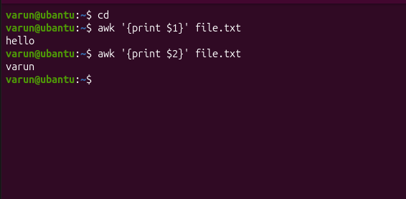
4. SED

5.SORT

6.CUT

7.UNIQ

8.WC

9.TEE
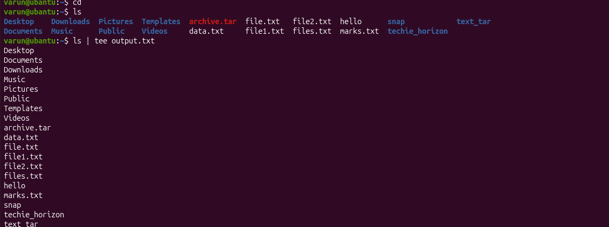
10.TAR
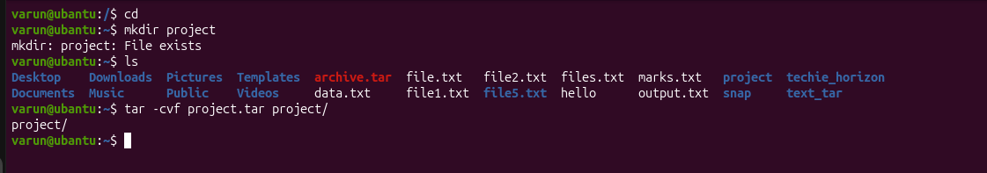
11.GZIP
